NHS Pharmacy Contraception Service – a guide to registration.

  - 11 December 2023

How is this service being commissioned?

This service is being commissioned as an Advanced pharmacy service. Therefore, participation is optional for all pharmacies. Contractors are required to meet the terms of the specification prior to registration.

The specification and PGDs can be found here:

NHS England » NHS Pharmacy Contraception Service

When did the extended Advanced Service go live?

The extended advanced service went live on 1 Dec 2023.

How do I register for the extended Pharmacy Contraception Service?

Contractors should register for the service via MYS:
MYS – Pharmacy | NHSBSA

- Contractors who are new to the service (from 1 Dec 2023)

Contractors that have never registered for the pharmacy contraception service should register when they are ready to start delivering consultations via the following link:

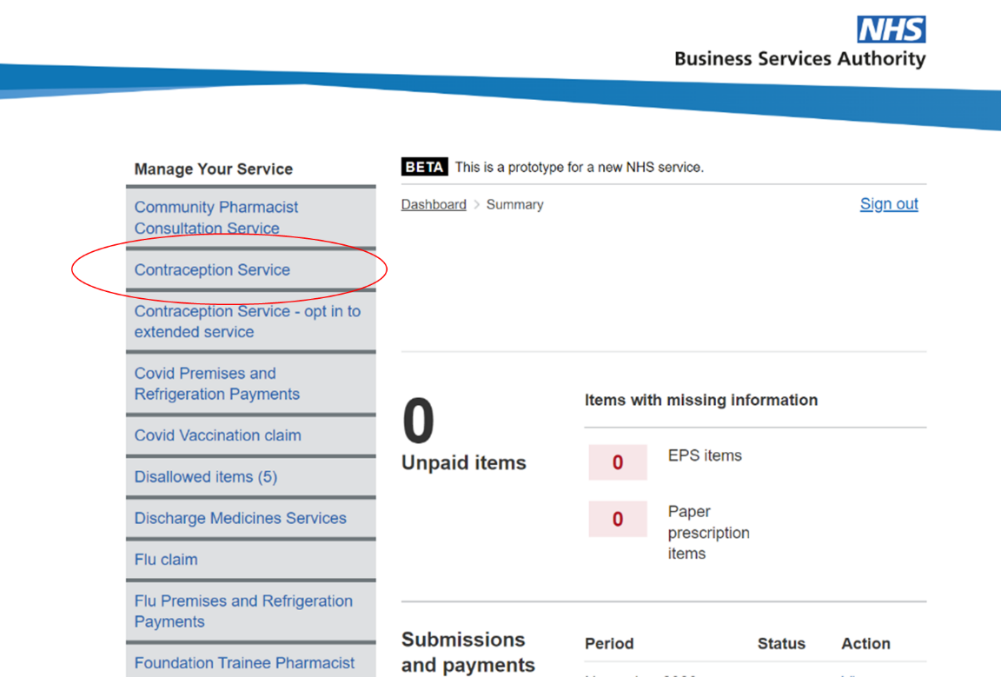

- Contractors who have previously registered for the service (before 1 Dec 2023)

Contractors who have previously registered for the advanced pharmacy contraception service should opt-in to the extended service when they are ready to start delivering all consultations (including initiation of oral contraception) via the following link:

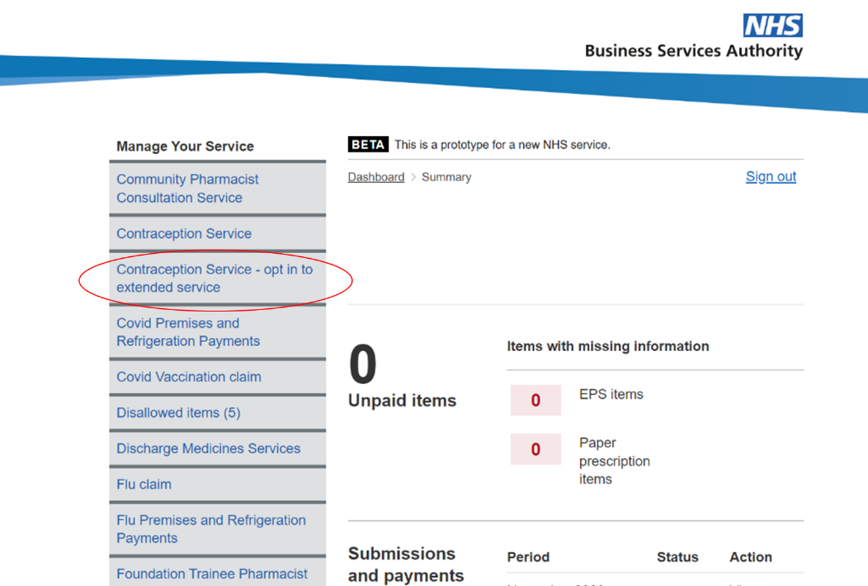

Contractors will have until 29th Feb 2024 to either opt-in to the extended service OR opt out of delivering the extended service via this route as shown below:

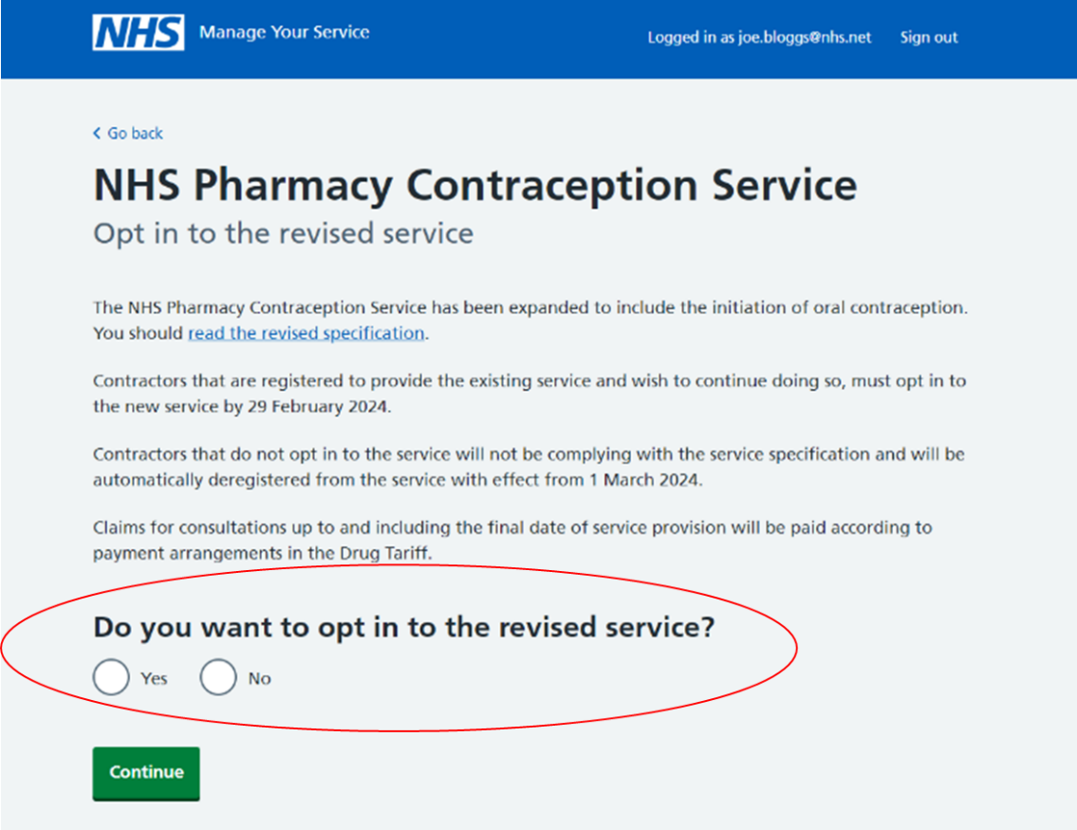

What happens if I chose to opt in?

Contractors will be directed to a declaration page as shown below. Once completed contractors will be registered for the new service and will be expected to deliver both ongoing supplies of oral contraception and initiation of oral contraception from that point onwards.

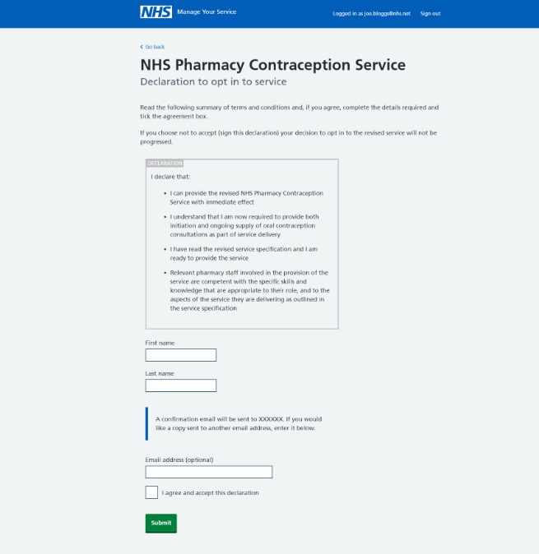

What happens if I chose to opt out?

Contractors who choose to opt out of delivering the extended pharmacy contraception service will be deregistered from the current Tier 1 service, but will be expected to continue delivering consultations for the next 30 days of their notice period (up to 29 Feb 2024).

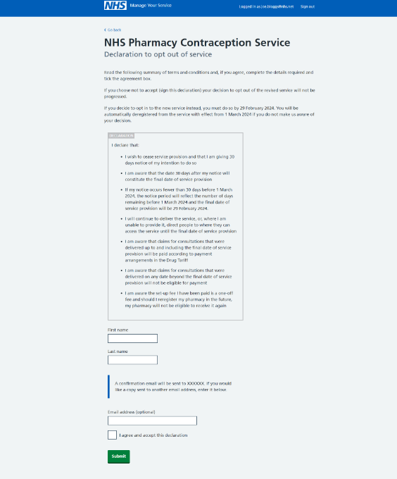

How will patients know about the service?

You can now search for a pharmacy that delivers the contraception service on:

Prescriptions and pharmacies - NHS (www.nhs.uk)

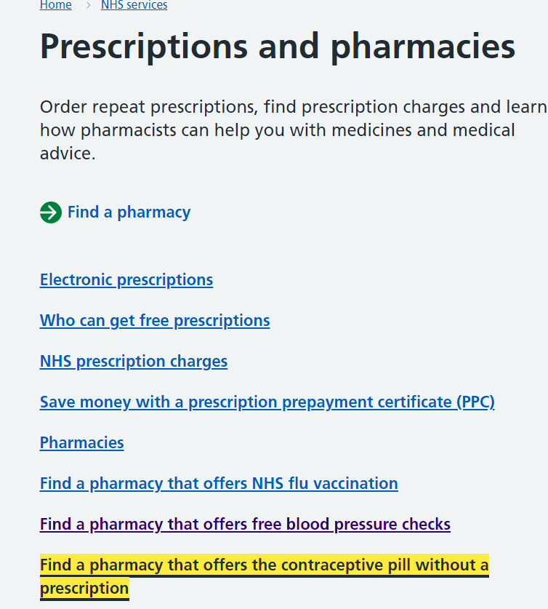

Once you access the link highlighted above you have the option to search for a pharmacy near to you:

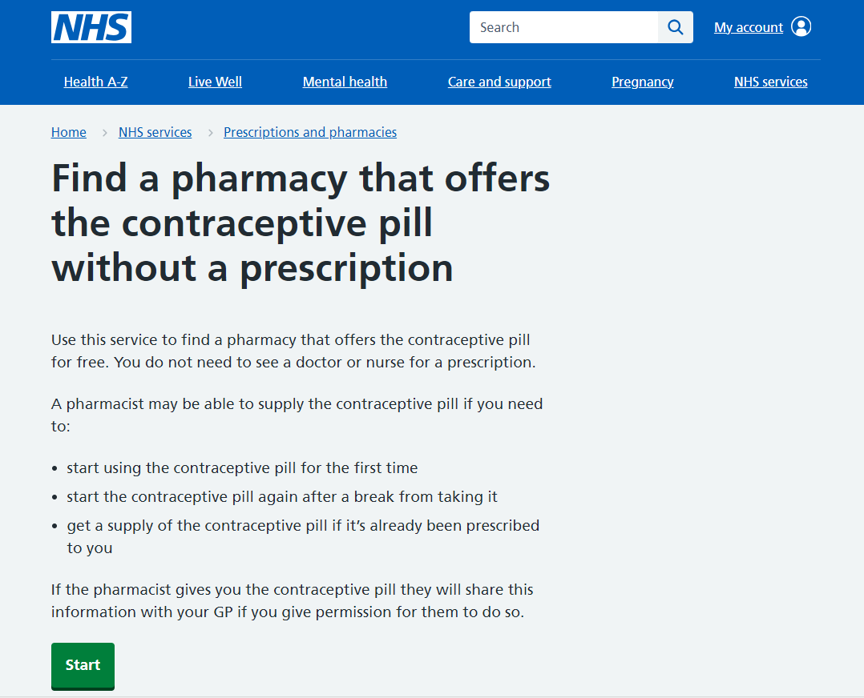
How will health professionals know which pharmacies can provide the service?

GPs and other health professionals can search on service finder to see which pharmacies are delivering the service.

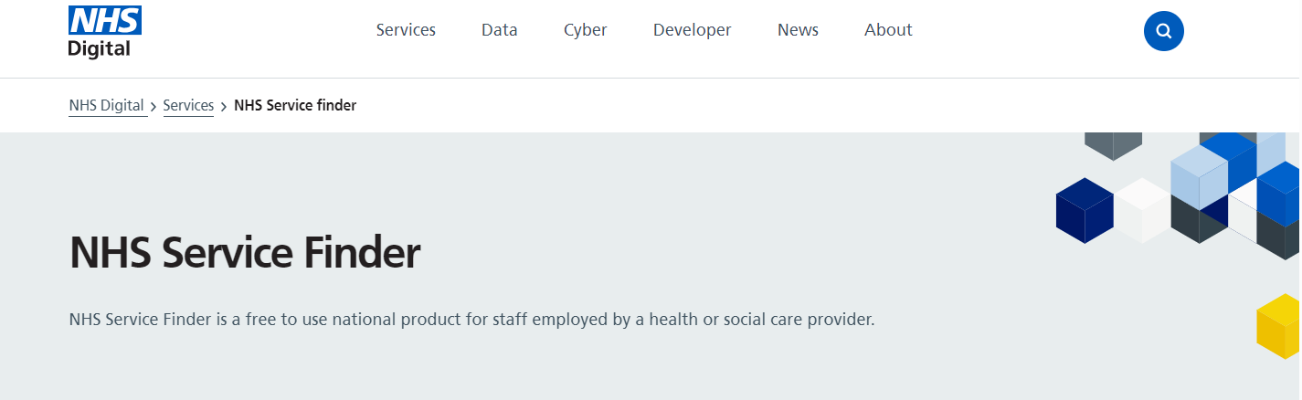

How will contractors ensure their pharmacy is listed on NHS.UK and service finder?

Contractors will need to ensure they keep profile manager updated with their current registration status.

How will I know who is registered?

All pharmacies that registered for the original contraception service are listed in the attached spreadsheet. All pharmacies on this list will need to either opt in or opt out. Anyone that does not complete this process will be de-registered on 1st March 2024.

Opt in reports and registration reports (for new registrants that have not signed up to the service before 1 December) will be issued weekly and can be found on:

Pharmacy Integration FutureNHS workspace, and Pharmacy Contract Teamspace MS Team.

Any NHSE team member that requires access to this should contact england.pharmacyintegration@nhs.net or england.communitypharmacy@nhs.net to gain access to one or both workspaces.

Will contraception be added to the SHAPE tool?

Yes, pharmacies that are registered for the contraception service will be visible on SHAPE by the new year. You will also have the ability to search for pharmacies that have delivered consultations. SHAPE - Shape (shapeatlas.net)

How will pharmacies market this service?

CPE has a number of support materials on their site
Pharmacy Contraception Service - Community Pharmacy England (cpe.org.uk)

NHSE are producing materials which include the following posters:

These will be hosted on the NHSE webpages very soon. In addition, they will be added to the CRC site Campaign Resource Centre (dhsc.gov.uk).

Translated materials will follow shortly.

